Lab 1

Submitted to:
Ma’am Yasmeen Jana
Submitted by:
Muhammad Faizan
Registration no:
FA22-BSE-052
Course:
Web Technologies

“Department of Computer Science”
COMSATS University Islamabad,
“Vehari Campus”

Activity 1:


Activity 2:
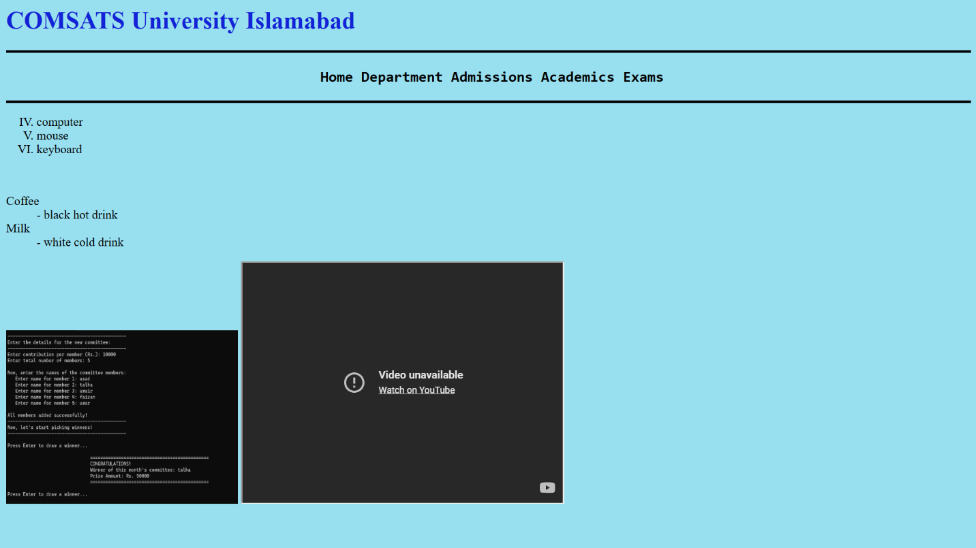

Task 1:
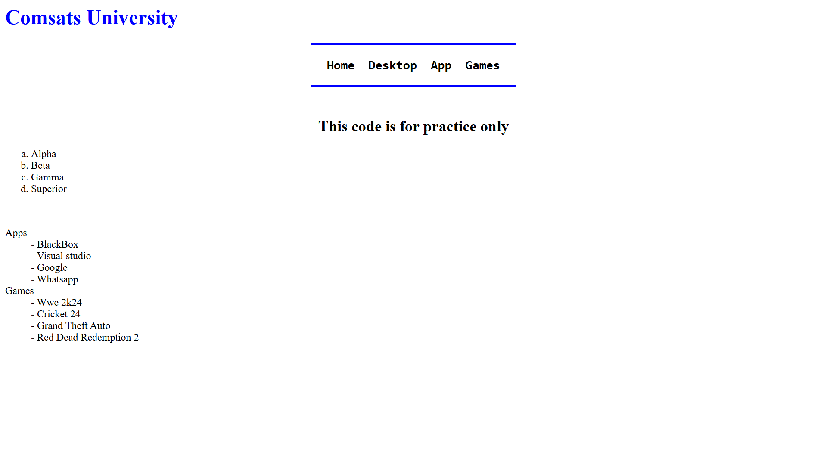

Task 2:
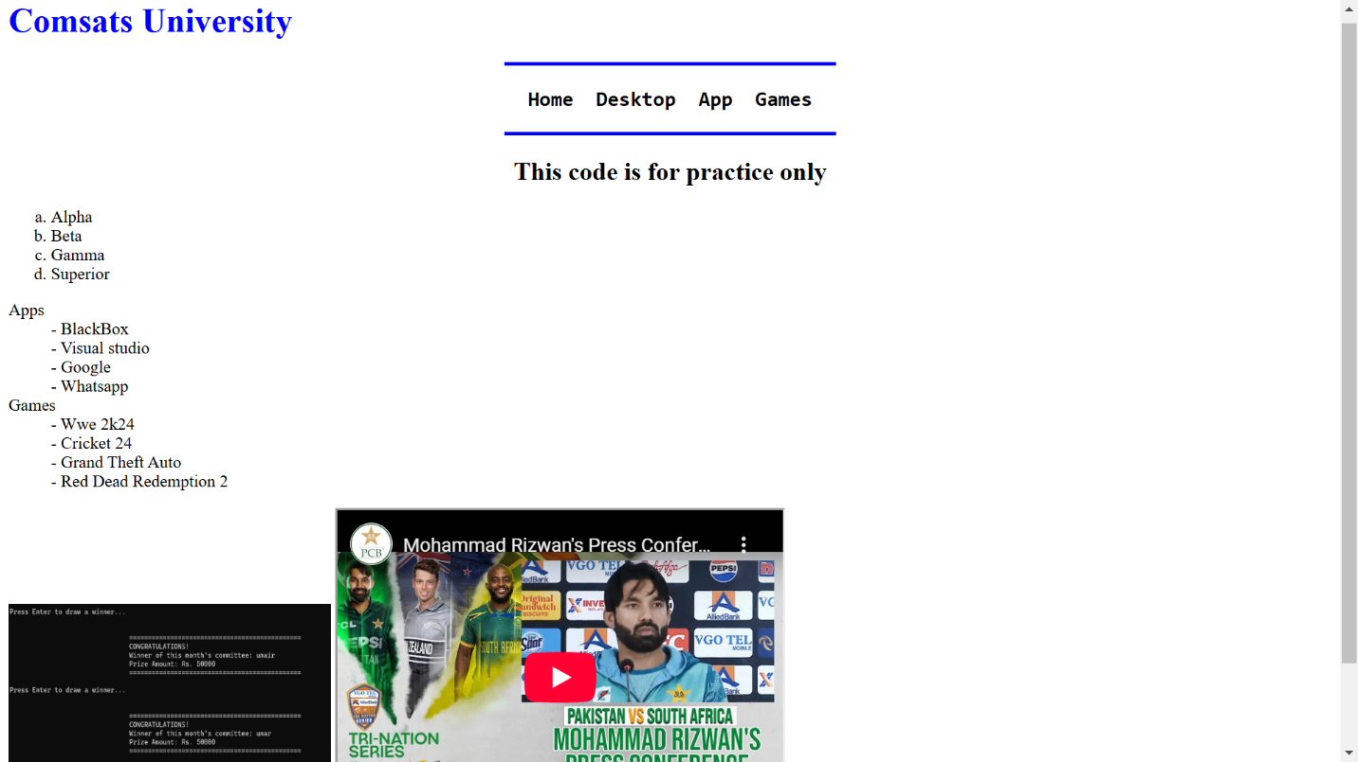

Task 3:
